Monte Carlo Simulation for the NBA Playoffs

For our project, we will be simulating the NBA playoffs. We will be implementing a Monte Carlo simulation. Monte Carlo simulation is a process of creating a large number of random samples that are used to generate a range of possible outcomes. These outcomes can then be used to estimate the probabilities of different scenarios. So to implement that process for the NBA playoffs, we will take each team and their win/loss statistics and find the probability that each team wins a certain matchup. We then will take a sample with those probabilities implemented, resulting in a winner from that match-up. We can then do this process in a conference bracket repeatedly to gain an estimate of how the conference will play out and an estimated winner.

The NBA playoffs are the postseason tournament of the National Basketball Association (NBA) held to determine the league’s champion. These games take place from the end of April through mid-June. The top 8 teams from the Eastern Conference and the top 8 from the Western Conference face off for the title of NBA champion. The top 6 teams in both conferences directly advance to the playoffs. Respectively ranked by their winning percentage, these teams are seeded 1-6. Teams ranked 7-10 compete in a play-in tournament. The winner of these play-in tournaments are given the chance to compete in the playoffs in the 7th and 8th seeds. The games are structured in a bracket format for each division, shown in Figure 1 below. Figure 1 accurately represents the teams facing off in this year’s playoffs and their respective conferences. The games are played in a best-of-seven elimination tournament, meaning the team must win four games to advance in the series. In the first round, seed 1 plays seed 8, seed 2 plays seed 7, seed 3 plays seed 6, and seed 4 plays seed 5. The winner of the first round will advance to the conference semifinals, the winner of the conference semifinals will advance to the conference finals, and lastly the winners of each conference finals will face off in the championship game.

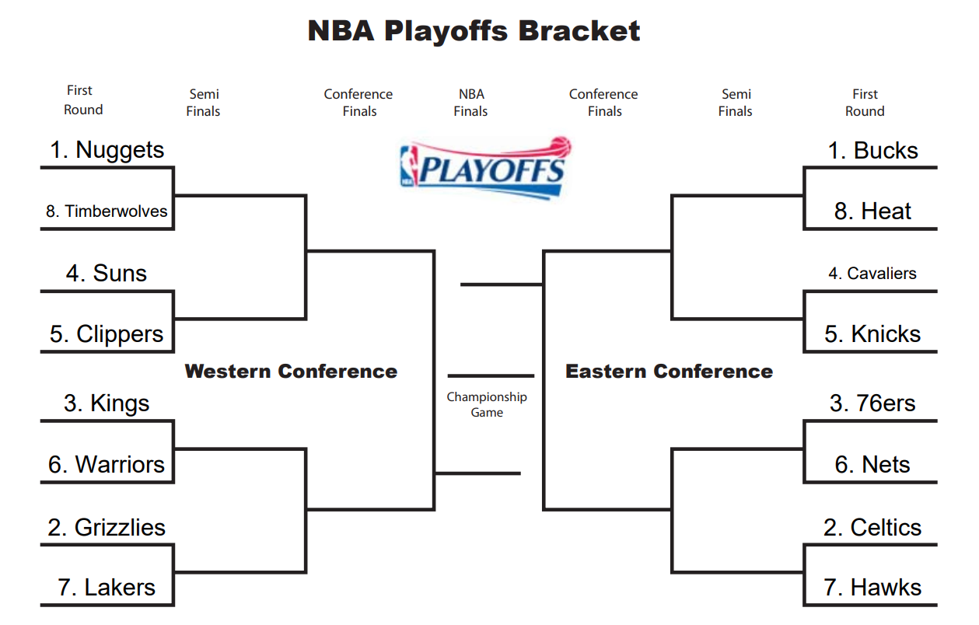

Figure 1

As big NBA fans, the idea for the project was to use Monte Carlo simulation to estimate the results of the playoffs. To implement this, we used R. The approach was to collect data, use the data to simulate game results and display the results. Luckily, NBA statistics are readily available online. The information needed for the project was team-based, such as name and winning percentage, compiled into a CSV file titled “nba_seeds.csv”. We looked at every possible combination of matchups between the teams in the playoffs and the probability that a particular team would defeat the other. This information is in the “games.csv” file. The winning percentage was used to determine a team’s probability of winning a match. A team’s winning percentage is a fundamental metric of their success and can be used to predict future matchups. Given that this data is readily available, we found this to be the simplest way to calculate the probability of a team winning a specific matchup. We used the approach explained in the article *Probabilities of Victory in Head-to-Head Team Matchups* by John Richards:

Let the winning percentages of teams A and B be calculated by WP $a_{}$ and WP $b_{}$

P $a_{}$ = $\frac{WPa_{}(1 - WPb)}{WPa_{}(1-WPb) + WPb(1-WPa)}$ and P $b_{}$ = $\frac{WPb_{}(1 - WPa)}{WPb_{}(1-WPa) + WPa(1-WPb)}$

In other words, the probability of each team’s victory is the ratio of its probability of victory to the probability of a decisive result. While this isn’t perfect since it doesn’t consider factors like home team advantage or injured team players, this is sufficient for our project, assuming each team has a balanced schedule. This is a safe assumption, given each NBA team plays each other at least twice in a season.

We then took these probabilities and built a Monte Carlo simulation in R to simulate the results of a playoff matchup. A function was created to simulate a winner of a game based on their winning percentage. Taking into account that the playoffs are played in a best of seven format, another function was created to simulate the matchup for seven games, stopping if a team reaches 4 wins. We ran the data through 100,000 simulations. The results of the bracket simulation are shown in Figure 2 below. These results are interesting yet practical. Given the winning percentage and rank of the Nuggets and Celtics, it makes sense that they would be in the finals. The games in the first round produced an expected result; the higher ranked teams beat the lower ranked teams. For the conference semifinals through the championship game, it didn’t necessarily follow that the higher ranked team won. This makes sense given the rankings and winning percentages were close between the advancing teams.

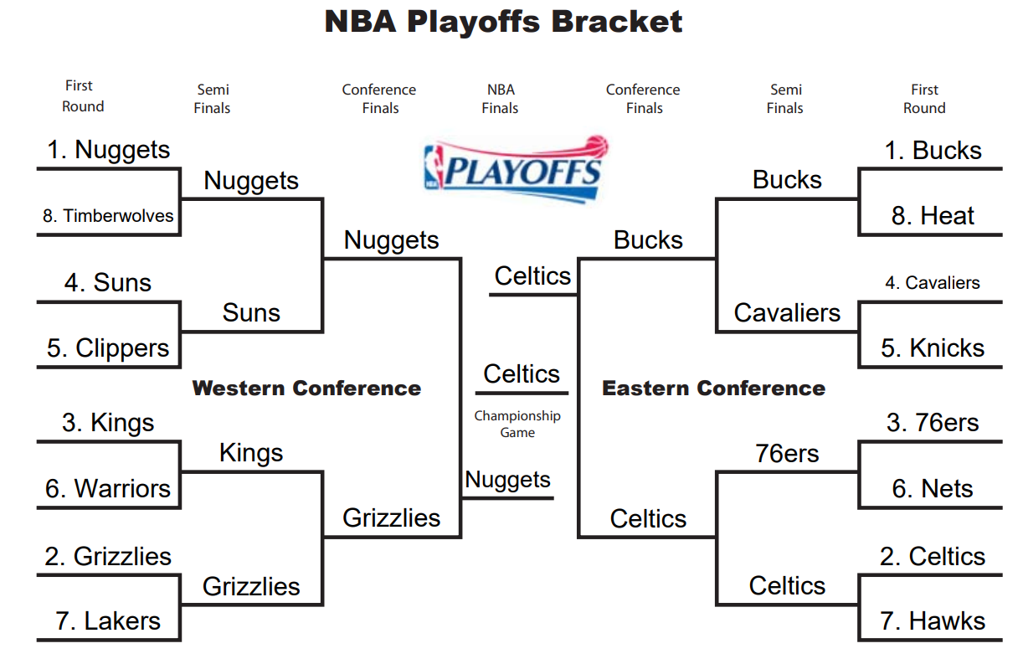

Figure 2

Shown in Table 3 below are the chances each team has of winning the championship game based on our simulation results. Given their regular season record, it makes sense for the Bucks and the Celtics to be at the top. This also confirms the results in our final bracket in Figure 2 above. It is interesting to see how low of a chance the Nets, Heat, Hawks, and Timberwolves have of winning the championship. I would expect it to be slightly higher even if their winning percentages were on the lower end compared to other teams.

| Team | Chance of Winning the Championship | Regular Season Winning Percentage |
| --- | --- | --- |
| Bucks | 25% | 70.7% |
| Celtics | 22% | 69.5% |
| Nuggets | 18% | 64.6% |
| Grizzlies | 11% | 62.2% |
| 76ers | 4% | 65.9% |
| Kings | 4% | 58.5% |
| Cavaliers | 3% | 62.2% |
| Knicks | 3% | 57.3% |
| Suns | 3% | 54.9% |
| Clippers | 3% | 53.7% |
| Warriors | 3% | 53.7% |
| Lakers | 1% | 52.4% |
| Nets | >1% | 54.9% |
| Heat | >1% | 53.7% |
| Hawks | >1% | 51.3% |
| Timberwolves | >1% | 51.2% |

One of the significant assumptions we made was that regular season team win percentages are strong predictors of a team’s playoff success. While these statistics hold some predictive power, it does not consider important factors like injured players. For example, while our projection has the Bucks with the highest chance of winning the finals, this team is actually already eliminated from the first round of the playoffs. Their star player, Giannis Antetokounmpo, was injured and out of the lineup. This definitely affected their loss. We are interested to see throughout the playoffs how accurate the rest of the predictions are. Obviously, there is no easy way to predict sports outcomes accurately, but Monte Carlo simulation is a good option.

Bibliography

Greer, J. (2023, April 8). *NBA playoff picture: Updated standings, Bracket, key dates for 2022-23 season*. Sporting News. Retrieved April 8, 2023, from https://www.sportingnews.com/us/nba/news/nba-playoff-picture-standings-bracket-dates-2022-23/pzjmavu9koolwujuxuhsirdv

Menyhért, K. (2021, January 11). *Predicting the outcome of the English Premier League by using Monte Carlo Method (in R)*. Medium. Retrieved April 8, 2023, from https://medium.com/swlh/predicting-the-outcome-of-the-english-premier-league-by-using-monte-carlo-method-in-r-638fbc90fd37

Mitchell, J. (2021, August 25). *The NFL Simulation: Monte Carlo Methods*. Medium. Retrieved April 8, 2023, from https://towardsdatascience.com/the-nfl-simulation-monte-carlo-methods-2f110424b1dd

*Monte Carlo simulation in R*. ProgrammingR. (n.d.). Retrieved April 8, 2023, from https://www.programmingr.com/monte-carlo-simulation-in-r/

*NBA Betting Odds & Lines: Draftkings sportsbook*. Sports Betting. (n.d.). Retrieved April 8, 2023, from https://sportsbook.draftkings.com/leagues/basketball/nba?wpsrc=Organic+Search&wpaffn=Bing&wpkw=https%3A%2F%2Fsportsbook.draftkings.com%2Fleagues%2Fbasketball%2Fnba&wpcn=leagues&wpscn=basketball%2Fnba

Richards, John A. “Probabilities of Victory in Head-to-Head Team Matchups.”

*Society for American Baseball Research*, 25 Oct. 2021, https://sabr.org/journal/article/probabilities-of-victory-in-head-to-head-team-matchups/.

*Teams traditional: Stats*. Teams Traditional | Stats | NBA.com. (n.d.). Retrieved April 8, 2023, from https://www.nba.com/stats/teams/traditional

*What is Monte Carlo Simulation?* IBM. (n.d.). Retrieved April 8, 2023, from https://www.ibm.com/topics/monte-carlo-simulation